# RESUME

Of

# Monirul Alam

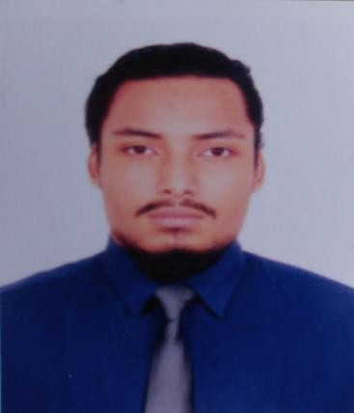**Contact Information:**

Mobile: +8801676725883

E- mail **:** ariyansnigdho@gmail.com   
 Address : 27 / A, jassim Uddi n Road,

Kamal apur , Dhaka

**CAREER OBJECTIVES**

To help myself, the organization and therefore the nation by utilizing my education, knowledge, skills, time and energy.

**EDUCATIONAL QUALIFICATION**

### Bachelor in Social Science (BSS)

 Institution : University of Liberal Arts Bangladesh (ULAB)

Department : Media Studies & Journalism

Duration : 4 years

Major : Public Relation

Minor : Business Administration

Result : **2.83 (out of scale 4.0)**

### Higher Secondary Certificate (HSC)

 Institution : Dhaka City College

Group : Commerce

Year of Passing : 2013

Result : **4.70 (out of scale 5.00)**

Board : Dhaka Education Board

### Secondary School Certificate (SSC)

* Institution : Ideal School and College
* Group : Commerce

Year of Passing : 2011

Result : **5.0 (out of scale 5.00)**

Board : Dhaka Education Board

**WORK EXPERIENCE**

* ***Customer Service Executive at PAKIZA AUTO.***  
    
  Job Description and Responsilbilities :
* It is an automobile car showroom and service centre, located and mugda bisshyoroad.
* I have worked in this company for one year in 2019
* My job was to handle customer problems and concerns and solve them according to my organization rules and regulations.
* Keeping records of works and services.
* ***Internship at The Daily Naya Diganta***Job Description and Responsilbilities :  
  + I did my internship during my last semester at The Daily Naya Diganta for four months.(September to December 2018)
  + I was assigned to edit news, photos and uploading it to online use portal.
  + I also covered one or two events and made a news story for my learning experience.
* ***Customer Care Executive at Genex infosys limited***

Job Description and Responsilbilities:

* I worked at Genex, which is a customer experience management centre, handles third party organizations customer support.
* I worked at genex for three months while I was an university student in 2017.
* My job was to listen to customer problems and help them with what they need.
* ***Data Entry Oparator at National Security Inteligence*** 
  + I did a contractual job here as a data entry operator back in 2013, which one an Two month long project.
* ***I also have some photography and videography and editing Experience. I create videos for social media for recreational purpose.***

d

* ***Expert level motorcycle driving skill. (I have won a couple of trophies here and there in motorcycle competitive sports)***

**LANGUAGE AND COMMUNICATION EFFICIENCY**

Good command over reading, writing, listening and speaking in both English & Bengali.

**Software Skills**

***Softwares that I am good at*** :

* Ms word
* Ms powerpoint
* Ms excel
* Internet Browsing & Researching.
* Adobe Photoshop and Lightroom.
* Video Editing.
* Also good skill in photography, videography.
* Also I have a Good typing speed in both English & Bengali.

**INTRAPERSONAL AND INTERPERSONAL STRENGTH**

* Capable of working in a stressful situation.
* Cope up with deadlines.
* Good sense of social responsibility.
* Dynamic, extrovert, and resourceful.
* Leadership and Commanding capability.
* Communicative, friendly, positive thinking attitude.
* Keeping my cool.

**HOBBIES AND EXTRA CURRICULER ACTIVITES**

* Any kind of risky Adventure activities.
* Motorcycle driving
* Playing guiter
* Swimming
* Workout and running
* Traveling
* Music, Movies, Books and Coffee.
* Photography and videography.

**PERSONAL DETAILS**

Name : Monirul Alam

Father’s Name : Md. Shahidul Alam Bhuiyan

Mother’s Name : Ferdous Ara Begum

Permanent Address : 27/A, jassim uddin road, kamalapur, dhaka Date of Birth : 5th December, 1996

Martial Status : Single

Sex : Male

Religion : Muslim

Nationality : Bangladeshi

Home District : Feni

## Declaration of Authenticity

I declare hereby that all information I have presented so far are true to my knowledge. If required and where applicable, this document can be supported by authentic certificates\papers.